Jake Guitard Lacasse 6255546
Vladyslav Ponomarchuk 6260039

JV STUDIOS Dungeon Crawler WPF App Report

- Dungeon Crawler Explained
  - A game where you play as a character, running through a dungeon slaying monsters and collecting loot to reach some form of goal or destination. This destination is impeded by a final boss in our application. The destination is merely the escape to win the game.
- Understanding the problem
- Inputs
  - Main Screens
    - Mouse clicks to change screens by clicking buttons
  - Game Screen
    - The movement commands for the player character (WASD keyboard keys)
    - Mouse clicks to change screens by clicking buttons
  - Inventory Screen
    - Mouse clicks to select items
    - Mouse clicks to switch screens by clicking buttons
  - Combat Screen
    - Mouse clicks to choose an action by clicking buttons
- Desired Output
  - Close the previous screen when changing screens
  - Inventory
    - Selecting an item with a left-mouse click in the inventory should output the description of the item in the bottom right textblock in the inventory screen
    - Clicking the ‘use’ button should remove the selected item from the list of items and apply the description of the item to the player’s stats but should not do anything when no item is selected
    - Clicking the use button should output “No items” somewhere if the last item is used. And that should be outputted anyway when inventory is opened if there are no items.
  - Game screen
    - When moving to a tile, all the items on that tile should be automatically picked up.
    - Using a movement command to enter the square with an enemy should instantiate combat with that enemy.
    - Moving to an escape should run a check if all the enemies are killed and let you win if they are.
    - Moving into walls stops you, you can’t go through walls.
  - Combat screen
    - You should be able to access your inventory during combat using the appropriate button.
    - Attack button should lower the health of the enemy
    - Block should reduce the damage dealt to you when the enemy attacks
    - Run away should skip the fight but not slay the enemy.
    - The enemy must act after you do.
  - Save button
    - Should save the map object data and player data to be loaded later. Opens the file dialog in windows.
  - Load button
    - Should load the map object and player object data that was previously saved. Opens the file dialog in windows.
- 2. Formulating the problem
  - All creatures have health, Defense and strength
  - Strength is numerical damage dealt on attack
  - Damage lowers the opponent’s health linearly
  - Defense is the reduction of damage when afflicted with an attack
  - Lose the game the moment health reaches 0
  - An enemy dies when it has 0 health, and should be removed
  - Description of item will add to any of the stats the player has numerically
  - The player cannot move on to the same coordinate as a wall
  - The map is stored as a list with numerical coordinates representing indexes
  - Movement commands are stored as incrementations of coordinates
  - Creatures have a level that mathematically increases their statistics.
- 3. Developing the problem
  - All button clicks should be made into methods that call various objects or processes.
  - Everything is a MapObject, which is then divided into different categories such as player, enemies, items, etc.
  - Some items are collidable, the player collides with them and can’t go over/through them.
  - The player is a creature
  - Enemies are creatures
  - Items are stored as a list
  - All items have a use function
  - Indexes are compared in the map list as a movement command is entered.
  - Walls, Items and creatures are checked for collision in this comparison depending on what happened to be located on that square at that time.
- 4. Implementing the problem
  - C# Object oriented programming paradigm using WPF application development will suffice here.
  - This is a required programming language to use here.
- 5. Testing
  - Inputting diagonal motion always processes a horizontal collision or vertical collision first successfully.
  - Opening multiple inventory tabs and using an item in only 1 of them removes the item from the list of all instances of the inventory successfully.
- 6. OOP design
  - Item for items
  - Creature for player and creatures
  - GameMap for map data
  - HealthPotion as an item to heal the player
  - Player is a creature but also the user’s interaction with the GameMap
  - Wall for impassable terrain.
  - Escape as a way to escape/win
  - StrengthPotion/DefensePotion as an item that improves the Player
  - SaverLoader to handle saving and loading.
  - IMapObject to represent a map object and enforce behaviours on these objects
  - ICollidable to mark a thing as collidable.
- 7. Contributions
  - Jake
    - Frontend
    - Report
    - UML diagram
    - WPF Screens’ interactions with each other
    - Everything else was greatly shared too granularly to accurately split credit
    - Most of the UML
  - Vlad
    - Backend (counts as 3 things)
    - Frontend connection to backend
    - Everything else was greatly shared too granularly to accurately split credit
    - Final polishing, bugfixes, etc.
- 8. Snapshots
- 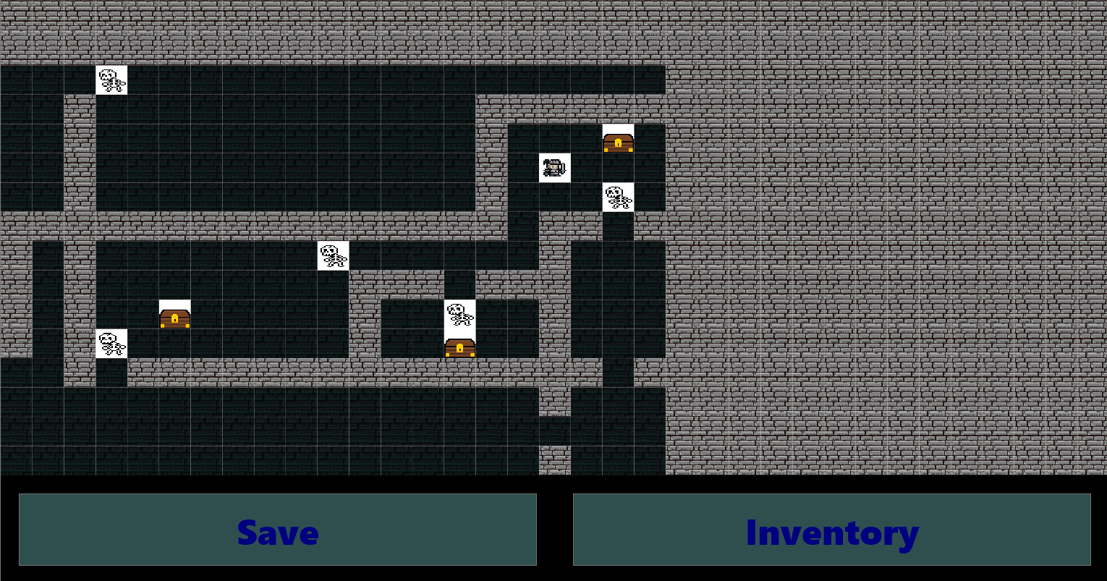
- 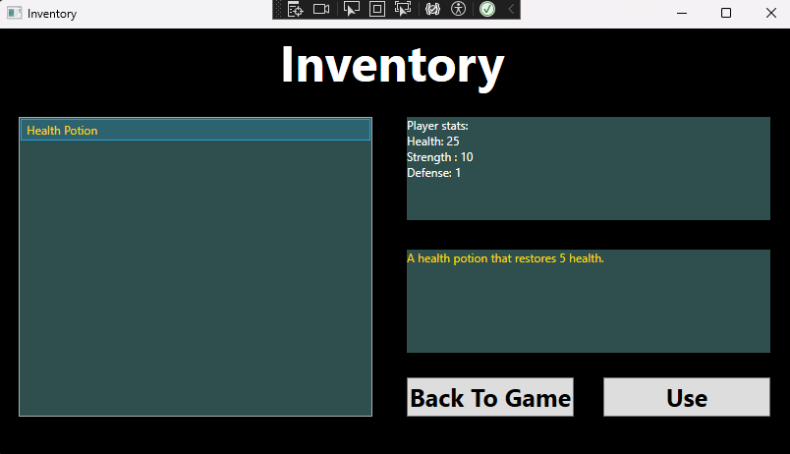
- 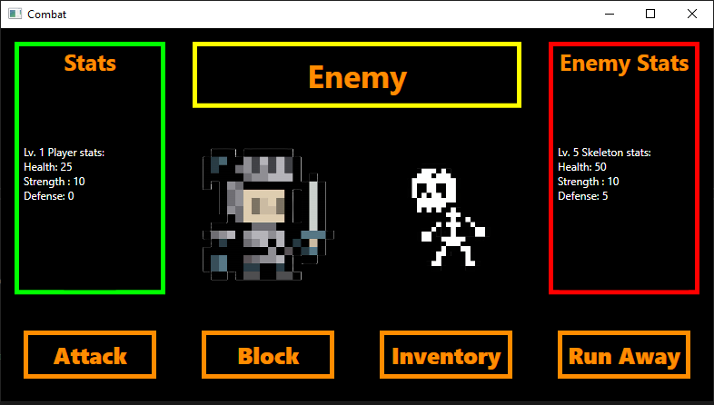
- Credit To third parties
  - knight.png by ObinSun (DeviantArt)
  - Floor.png from “Jump King” video game
  - Chest.png by Dan Sevenstar (OpenGameArt.org)
  - Escape.png is a free texture from the internet
  - skeleton.png by turtlesrfun (DeviantArt)
  - wall.png by ThatsPrettyNeat (Pixilart)
- Future Work that would benefit the app but didn’t make it in
  - Features include…
    - Randomized map generation
    - Multiple maps and movement between them
    - Randomized enemy levels
    - Harder difficulties with larger maps and tougher monsters
    - Different kinds of monsters
    - Different kinds of potions, maybe even equipment
    - Experience, level up, skills, etc.
- Team Contract
- Appendix A: Team Contract Template
- This is an informal contract to ensure that all team members have a common understanding of what is expected in terms of work standards, communication, division or work, and conflict resolution.
- Team Members (Name & ID)
 | Name | Student ID
Member A: | Jake Guitard Lacasse | 6255546
Member B: | Vladyslav Ponomarchuk | 6260039

- Strength & Weaknesses
- Within the context of this project, what are the strengths and weaknesses that each member brings to the team?

- Member A: Strength: WPF Weakness: Robust code
- Member B: Strength: It gets done Weakness: WPF

- Definition of “good enough” for this project
- What would the team collectively consider “good enough” of an achievement for the project?
- Single map, all hard-coded item and enemy positions, implemented combat and inventory, game over condition (death/victory)

- Picked Topic
- Dungeon Crawler

- Division of work
- How will each member contribute to the project?
- Member A: Front End (WPF, etc.)
- Member B: Back End (Game logic, etc.)

- Frequency of communication
- How often will the team be in touch and what tools will be used to communicate?
- Discord, always in touch
- Response delays
- 1-2 hours on average
- What is a reasonable delay to reply to messages? Is it the same for weekdays and weekends?
- A day, same for entire week

- Receiving feedback
- Each member must provide a sample sentence for how they would like to receive constructive feedback from their peers.
- (If unsure, assume a hypothetical situation such as you have not completed your work in time or you have not replied to a message in a timely manner).

- Member A: Doesn’t matter.
- Member B: I’m indifferent, as long as the job gets done.

- In case of conflict
- If a team member fails to communicate as described in this contract or does not respond to constructive feedback, what measures should the other teammate take?
- Contact Aref.
- Appendix B UML Diagram
(If this doesn’t work, check the Documents folder)

